1.32:
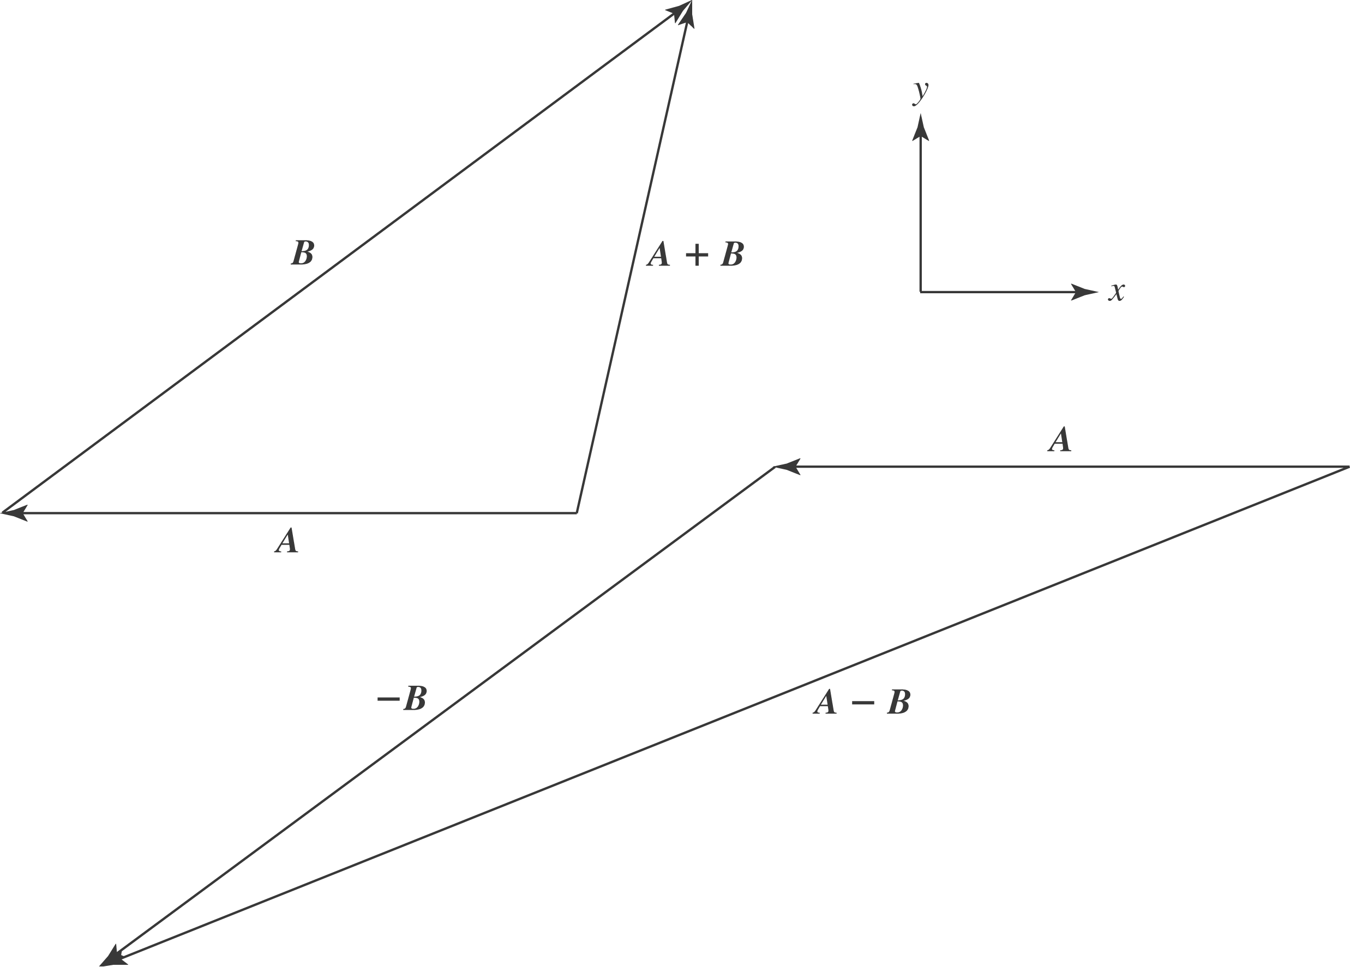

- 11.1 m @ 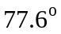
- 28.5 m @ 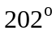
- 11.1 m @ 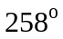
- 28.5 m @ 